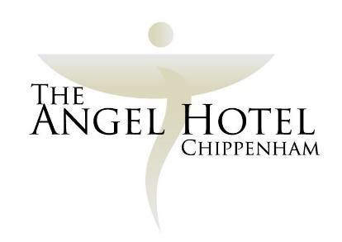

Accessibility Guide for The Angel Hotel

Contact for accessibility enquiries: reception@angelhotelchippenham.co.uk, 01249 652615,

We aim to confidently ensure that all our guests have comfortable facilities, all requests are dealt with efficiently and everyone is made to feel welcome throughout their stay. As far as possible we will accommodate the requirements of all our guests. We will explain our facilities and how they may meet guests’ particular requirements.
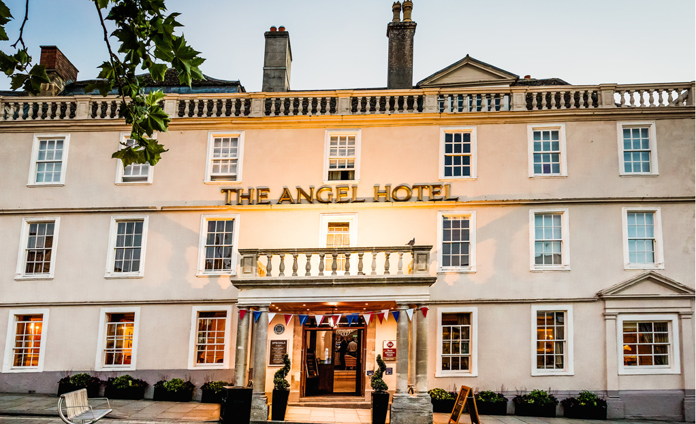

Welcome
The Angel Hotel Chippenham Wiltshire is a delightful 17th Century coaching inn set in the market town of Chippenham. In fact, it overlooks the Market Place itself, giving guests convenience and character in abundance! We have recently refurbished the bar, lounge and reception area of the hotel. The new look of the hotel offers something modern yet respecting the heritage of the Angel Hotel.
At the Angel Hotel Chippenham, Wiltshire we have 50 bedrooms, all of which have been recently refurbished. 15 rooms of individual character are located in the main house with an additional 35 modern executive rooms situated in the courtyard wing.
You’ll be able to relax in the hotel’s leisure club and walled courtyard garden.
A small hotel with lots of character, the Angel Hotel Chippenham Wiltshire offers homely, welcoming service at all times. Our friendly staff make this a wonderful place to spend time at, and an even more inviting place to return to after a day at one of the many nearby beauty spots.

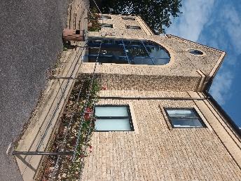
Parking
- There is parking at the venue. There are 3 accessible parking spaces.
- The car park is within close proximity of the rear entrance. Parking is free and all vehicles need to be registered on screen at reception.
- There is a drop-off point at the main entrance. The drop-off is in front of the main doors.
- From the car park to the entrance there are steps and a ramp.
- There is not a lift within the building.

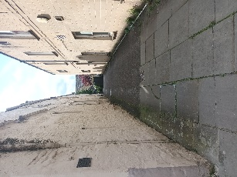
Arrival

Path to main entrance
- From the street to the main entrance, there are 2 steps into the building.
- Accessible access from the street down the side of the main building.

Main entrance
- The main entrance has level access; there are 2 steps up to the main hotel reception.
- The leisure facilities are level access.
- The main door is hinged and not automatic.
- The main hotel entrance door is approx.1000mm wide.
- The spa doors are approx. 1700mm wide.
Reception
- All ground floor doors in the main building are open during normal service hours.
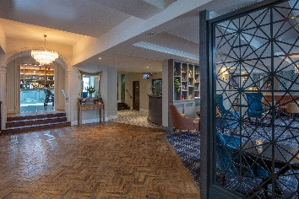
- There are steps to get to the main reception.
- The reception area has seating available for guests checking in and a lounge area is situated nearby.
- Reception staff can assist guests with luggage.
- When checking-in, reception staff will note if guests need assistance in the event of an evacuation. PEEPS required for single occupancy guests.

Public rooms in the hotel
- The whole of the ground floor is accessible to wheelchairs – as is the garden.
- The gym within the leisure facilities is on one level however steps are required to enter the swimming pool.
- The hotel bar is on the ground floor – there are no steps.
- There is a small lounge on the ground floor and waiter service is available.
- All corridors and public areas are well lit.
- All doors and corridors are wide enough for wheelchairs/zimmer frames/pushchairs.
- There is a disabled toilet on the ground floor that is suitable for wheelchairs and has baby-changing facilities.
- All diets can be catered for although advance notice is helpful.
- Food & drink service is available in all public areas.
- Highchairs are available and may be used in all areas.
The restaurant lighting is even but can be varied.
- Service dogs are allowed in the hotel.
- We can provide water bowls for assistance dogs on request.
- Wi-Fi is available Free of Charge throughout the public rooms and all the bedrooms.

Meeting rooms
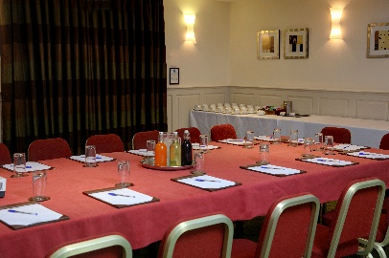
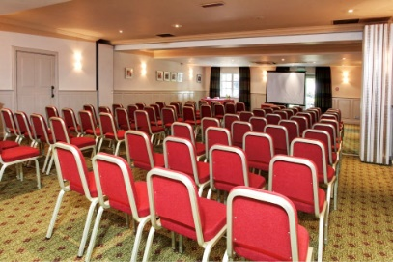

- Our main meeting rooms are easily accessible from the main car park.
- The main meeting rooms can accommodate 2 – 100 delegates.
- The male, female, and accessible toilets are available opposite the main meeting rooms.
- There is an additional function room on the 1st floor, accessible by stairs that can accommodate 12 delegates.
- Free Wi-Fi is available in our meeting rooms.
- Private dining is available in all our meeting rooms and function suites.

Bedrooms
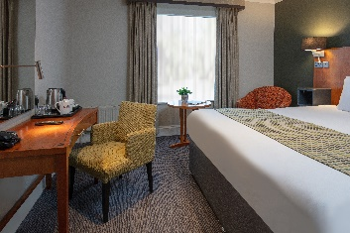
- We have 12 ground floor rooms
- Of the ground floor rooms, 2 are easy access rooms suitable for those with restricted mobility and have wet rooms. These rooms are available as single, twin or double room.
- 8 of the rooms have walk in showers with a small ledge to enter the
    - shower, and 2 rooms have showers over low rise baths.
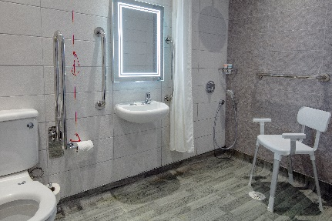
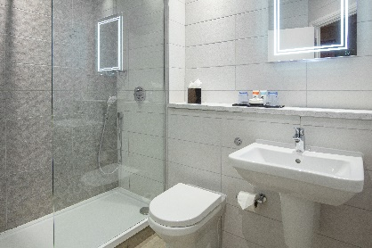

- We have a direct dial telephone, fire alarm and smoke alarms in every bedroom.
- The bedrooms and bathrooms are generously proportioned, but some provide more turning and transfer space than others.
- We try as far as possible to allocate bedrooms based upon individual guest needs.
- Emergency procedures are posted on the door to each bedroom and are explained upon check in for any disabled guests upon request.
- Every bedroom has a digital television with remote control.
- There are bedside lights.
- All our bedding is non-allergenic.
- All rooms are non-smoking in compliance with current legislation.
- Furniture within the rooms can be moved.
- Every bedroom is carpeted.
- Bedroom lighting can be switched on at the entrance to the room and within the room.
- All bathrooms have non-slip floor shower mats.
- Bathroom lighting is very bright, and all sanitary ware is white.

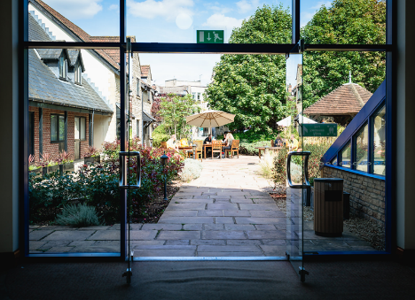
Getting around outside

The new building and the main building are linked by the
garden

Hearing
- The fire alarm has flashing lights.
- A deaf guard is available from reception

Emergency evacuation procedures
- We have emergency evacuation procedures for disabled visitors.
- The fire alarm has flashing lights.

Customer care support
- Baby changing facilities and highchairs are available.

Getting here
The Angel Hotel
8 Market Place
Chippenham
SN15 3HD meant.supply.dairy

Travel by public transport

- You can get to The Angel Hotel using any of the following taxi service: Veezu – 01249 656565 The taxi companies have a wheelchair accessible vehicle if requested.

- Chippenham Bus Station is approx. 305ft.

- Chippenham Train Station is approx. 0.4miles.

Although we have tried to be as accurate and include as much detail as we can in our Access Statement, we are always willing to give information on any aspect of the hotel if this statement does not answer your query.

